Input/Output Devices

Contents:

Introduction
- Input Devices
  - Keyboard,mouse,joystick,scanners,digital camera, bar code reader, touch Sreeen,Speech input device (microphone)
- Output Devices
  - Monitor , Speaker, Printers ( different types)

-----------------------------------------------------------------------------------------
-

- Introduction

The computer will be of no use unless it is able to communicate with the outside world. Input/Output devices are required for users to communicate with the computer. In simple terms, input devices bring information INTO the computer and output devices bring information OUT of a computer system. These input/output devices are also known as peripherals since they surround the CPU and memory of a computer system.
Some commonly used Input/Output devices are listed in table below.

Input Devices | Output Devices
Keyboard | Monitor
Mouse | LCD
Joystick | Printer
Scanner | Plotter
Light Pen
Touch Screen

Input Devices
- Keyboard
It is a text base input device that allows the user to input alphabets, numbers and other
characters. It consists of a set of keys mounted on a board.

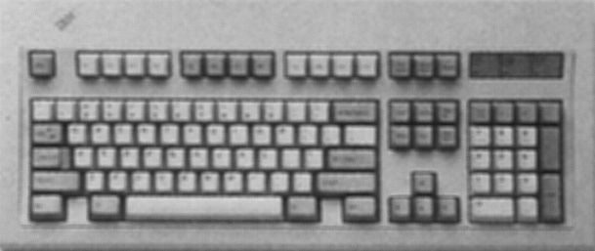Alphanumeric Keypad/ Special-function Keys

Function Keys

Cursor Movement Keys

Numeric Keypad

Alphanumeric Keypad
Figure 1: The Keyboard

It consists of keys for English alphabets, 0 to 9 numbers, and special characters like +
− / * ( ) etc.
Function Keys
There are twelve function keys labeled F1, F2, F3… F12. The functions assigned to these keys differ from one software package to another. These keys are also user programmable keys.
Special-function Keys
These keys have special functions assigned to them and can be used only for those specific purposes. Functions of some of the important keys are defined below.
Enter
It is similar to the ‘return’ key of the typewriter and is used to execute a command or program.
Spacebar
It is used to enter a space at the current cursor location.
Backspace
This key is used to move the cursor one position to the left and also delete the character in that position.
Delete
It is used to delete the character at the cursor position.
Insert
Insert key is used to toggle between insert and overwrite mode during data entry.
Shift
This key is used to type capital letters when pressed along with an alphabet key. Also used to type the special characters located on the upper-side of a key that has two characters defined on the same key.
Caps Lock
Cap Lock is used to toggle between the capital lock features. When ‘on’, it locks the alphanumeric keypad for capital letters input only.

Tab
Tab is used to move the cursor to the next tab position defined in the document. Also, it is used to insert indentation into a document.
Ctrl

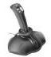
Control key is used in conjunction with other keys to provide additional functionality on the keyboard.
Alt
Also like the control key, Alt key is always used in combination with other keys to perform specific tasks.
Esc
This key is usually used to negate a command. Also used to cancel or abort executing programs.
Numeric Keypad
Numeric keypad is located on the right side of the keyboard and consists of keys having numbers (0 to 9) and mathematical operators (+ − * /) defined on them. This keypad is provided to support quick entry for numeric data.
Cursor Movement Keys
These are arrow keys and are used to move the cursor in the direction indicated by the arrow (up, down, left, right).

- Mouse
The mouse is a small device used to point to a particular place on the screen and select in order to perform one or more actions. It can be used to select menu commands, size windows, start programs etc.
The most conventional kind of mouse has two buttons on top: the left one being used most frequently.
Mouse Actions
Left Click : Used to select an item.
Double Click : Used to start a program or open a file.
Right Click : Usually used to display a set of commands.
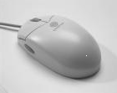
Drag and Drop : It allows you to select and move an item from one location to another. To achieve this place the cursor over an item on the screen, click the left mouse button and while holding the button down move the cursor to where you want to place the item, and then release it.

Figure 2: The Mouse

- Joystick
The joystick is a vertical stick which moves the graphic cursor in a direction the stick is moved. It typically has a button on top that is used to select the option pointed by the cursor. Joystick is used as an input device primarily used with video games, training simulators and controlling robots

Figure 3: The Joystick

- Scanner
Scanner is an input device used for direct data entry from the source document into the computer system. It converts the document image into digital form so that it can be fed into the computer. Capturing information like this reduces the possibility of errors typically experienced during large data entry.

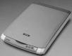

Figure 4: The Scanner

Hand-held scanners are commonly seen in big stores to scan codes and price information for each of the items. They are also termed the bar code readers.
- Bar codes
A bar code is a set of lines of different thicknesses that represent a number. Bar Code Readers are used to input data from bar codes. Most products in shops have bar codes on them.Bar code readers work by shining a beam of light on the lines that make up the bar code and detecting the amount of light that is reflected back
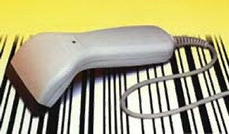
Figure 5: The Bar Code Reader

- Light Pen

It is a pen shaped device used to select objects on a display screen. It is quite like the mouse (in its functionality) but uses a light pen to move the pointer and select any object on the screen by pointing to the object.
Users of Computer Aided Design (CAD) applications commonly use the light pens to directly draw on screen.
- Touch Screen
It allows the user to operate/make selections by simply touching the display screen. Common examples of touch screen include information kiosks, and bank ATMs.
- Digital camera
A digital camera can store many more pictures than an ordinary camera. Pictures taken using a digital camera are stored inside its memory and can be transferred to a computer by connecting the camera to it. A digital camera takes pictures by converting the light passing through the lens at the front into a digital image.
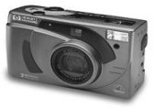
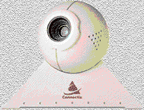

- The Speech Input Device
Figure 6: The Digital camera

The “Microphones - Speech Recognition” is a speech Input device. To operate it we require using a microphone to talk to the computer. Also we need to add a sound card to the computer. The Sound card digitizes audio input into 0/1s .A speech recognition program can process the input and convert it into machine-recognized commands or input.
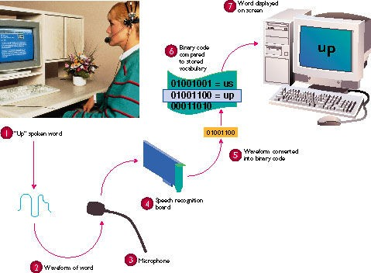

Figure 7: The Microphone

Output Devices

- Monitor
Monitor is an output device that resembles the television screen and uses a Cathode Ray Tube (CRT) to display information. The monitor is associated with a keyboard for manual input of characters and displays the information as it is keyed in. It also displays the program or application output. Like the television, monitors are also available in different sizes.
- Liquid Crystal Display (LCD)
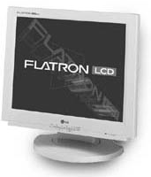
LCD was introduced in the 1970s and is now applied to display terminals also. Its advantages like low energy consumption, smaller and lighter have paved its way for usage in portable computers (laptops).

- Printer
Figure 8: The LCD

Printers are used to produce paper (commonly known as hardcopy) output. Based on the technology used, they can be classified as Impact or Non-impact printers.
Impact printers use the typewriting printing mechanism wherein a hammer strikes the paper through a ribbon in order to produce output. Dot-matrix and Character printers fall under this category.
Non-impact printers do not touch the paper while printing. They use chemical, heat or electrical signals to etch the symbols on paper. Inkjet, Deskjet, Laser, Thermal printers fall under this category of printers.
When we talk about printers we refer to two basic qualities associated with printers: resolution, and speed. Print resolution is measured in terms of number of dots per inch (dpi). Print speed is measured in terms of number of characters printed in a unit of time and is represented as characters-per-second (cps), lines-per-minute (lpm), or pages-per-minute (ppm).
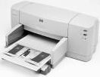

Figure 9: The Printer

- Plotter
Plotters are used to print graphical output on paper. It interprets computer commands and makes line drawings on paper using multicolored automated pens. It is capable of producing graphs, drawings, charts, maps etc.
Computer Aided Engineering (CAE) applications like CAD (Computer Aided Design) and CAM (Computer Aided Manufacturing) are typical usage areas for plotters.
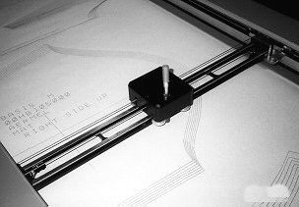

Figure 10: The Plotter

- Audio Output: Sound Cards and Speakers:

The Audio output is the ability of the computer to output sound. Two components are needed: Sound card – Plays contents of digitized recordings, Speakers – Attached to sound card.

Summary:

The Chapter has given an introduction to the Input/Output devices. It gives a detailed listing of the various types of input devices and the output devise. The concepts are also very clearly understood by seeing at the figures in the chapter.

